ATTACHMENT 1 – CONDITIONS OF APPROVAL

Council has imposed the following conditions under the relevant planning instruments and policies.

A. THE DEVELOPMENT

Approved Plans

- Development the subject of this determination notice must be carried out strictly in accordance with the following approved plans / reports marked as follows, except where modified by the undermentioned conditions.

Plan Name | Plan Number | Date | Prepared By
Basement Envelope Plan | MP-002 | 2/05/2020 2/02/2021 | FJMT
Envelope Plan | MP-001 | 2/05/2020 16/09/2020 | FJMT
Envelope Section A | MP-005 | 2/05/2020 2/02/2021 | FJMT
Envelope Section B & C | MP-006 | 2/05/2020 2/02/2021 | FJMT
Envelope Perspective North | MP-003 | 2/05/2020 16/09/2020 | FJMT
Envelope Perspective South | MP-004 | 2/05/2020 | FJMT
Envelope Perspective East | MP-007 | 2/05/2020 | FJMT

Environmental Planning and Assessment Act 1979

- In accordance with section 4.22(4) of the EP&A Act all development under the Concept Proposal must be subject of future application(s). This consent does not permit the carrying out of any works.

Land Uses

- This consent does not approve any residential land uses other than boarding houses on the subject site.

Public Domain and Landscaping – Design Excellence

- A Public Domain Design Panel is to be convened and a Public Domain Plan prepared:

  - Prior to the determination of any Detailed DA subject to this Concept Approval, a detailed Public Domain and Landscape Plan must be prepared by a suitably qualified AILA Registered Landscape Architect or Urban Designer, in accordance with the requirements of this condition.

  - A design review process is to be undertaken for the Public Domain and Landscape Plan with the purpose of achieving design excellence of the public domain in accordance with Clause 7.5 of Liverpool Local Environmental Plan 2008.

  - As part of the design review process, a Public Domain Design Panel is to be convened, that is to be chaired by the nominated chair of Council’s Design Excellence Panel or his or her nominee, and whose other members are to include (at least):

- A representative of or person nominated by Government Architect NSW;
- A suitably qualified landscape architect and urban designer;
- A representative of Liverpool City Council’s City Design and Public Domain team.

  - At least two public domain design workshops are to be convened for attendance by members of the Public Domain Design Panel, the Applicant, and other relevant technical officers of Liverpool City Council which may include officers responsible for Heritage, Traffic, Public Art, Community Planning, Indigenous Culture and Heritage, and Community Development.

  - At the conclusion of the public domain design workshops, the Public Domain Design Panel is to record its recommendations.

  - The recommendations of the Public Domain Design Panel are to be incorporated into a Public Domain and Landscape Plan to be prepared by the Applicant.

  - The Public Domain and Landscape Plan is to be endorsed by the Chair of the Public Domain Design Panel as satisfactorily responding to the outcome of the public domain workshops, prior to the determination of any future Detailed DA under this Concept Approval.

- The Public Domain and Landscape Plan is to:

  - Identify any landscape constraints, including (but not limited to) setbacks, existing street trees, landscape features, screening / buffer requirements
  - Include public domain design guidelines that are to be implemented across the subject site
  - Identify the location of public domain areas within the site, providing detail on their role, character and extent
  - Set aspirations and principles for each public domain area in order to achieve Design Excellence in accordance with Clause 7.5 of Liverpool Local Environmental Plan 2008
  - Identify the location of trees, planters, water sensitive urban design treatments, deep soil and direct sunlight to public domain areas
  - Detail design principles for roof terraces, including (but not limited to) how planting, deep soil, access and shade would be implemented
  - Identify any intended design elements such as green roofs and walls, water sensitive landscape design treatments and sustainability targets
  - Demonstrate consistency with the relevant landscape provisions of the Liverpool Development Control Plan 2008 and Liverpool City Centre Public Domain Master Plan
  - Demonstrate how the public domain areas will relate to proposed future built form within site, including consideration of pedestrian movements to and between buildings within the site

- All future detailed Development Applications subject to this Concept approval will need to demonstrate to the consent authority consistency with the endorsed Public Domain and Landscape plan.

Traffic and Access

- Prior to the determination of a Detailed DA, a Local Area Traffic Management Plan is to be submitted to Council’s Traffic and Transport Section and to the Liverpool Pedestrian Active Transport and Traffic Committee for endorsement. The Local Area Traffic Management Plan is to identify traffic infrastructure improvements including changes to the adjoining traffic signals, signs, line markings and timed parking restrictions.

Transport for NSW Conditions

- Future Detailed DAs subject to this Concept Approval shall comply with all conditions provided by Transport for NSW dated 12 August 2020. A copy of the conditions is attached to this decision notice (Attachment 1). Note: the conditions do not constitute a Section 138 concurrence under the Roads Act 1993.

B. CONDITIONS TO BE SATISFIED PRIOR TO THE SUBMISSION OF FUTURE DEVELOPMENT APPLICATIONS

Pre-Development Application Meeting

- Prior to the submission of a development application which seeks approval for any detailed design of a building under this Concept Approval, a Pre-Development Application meeting is to be convened with representatives of Liverpool City Council. Advice of the subject Pre- Development application meeting is to accompany the development application when lodged.

Amended Plans

- Prior to the lodgement of any Detailed DA subject to this Concept Approval, the plans outlined in Condition 1 must be amended to reflect the following:

  - The extent of the building envelope titled ‘Masterplan Envelope – Information & Education Facility’ must be reduced to a maximum of 4 metres from the eastern edge of Lot 201 in DP 1224084, also known as 306-310 Macquarie Street (excluding any decorative architectural features above ground level). Evidence is to be provided to Liverpool City Council’s Manager Development Assessment that satisfactorily demonstrates the plans have been amended to reflect this condition.

C. CONDITIONS TO BE SATISFIED IN FUTURE DEVELOPMENT APPLICATIONS
Building Envelopes

- Built form proposed in any future Detailed DA subject to this Concept Approval is not permitted to extend beyond the building envelopes approved under DA-585/2019.

- Any built form proposed within the building envelope titled ‘Masterplan Envelope – Information & Education Facility’ must incorporate the following requirements:

  - Floors facing the north western façade of the existing mixed-use building at 300 Macquarie Street, Liverpool, are to incorporate design features that limits overlooking into existing residential areas.

Public Domain and Landscaping – Design Excellence

- All future detailed Development Applications subject to this Concept Approval are to demonstrate consistency with an endorsed Public Domain Plan, detailed in Conditions 4 and 5.

Stormwater Management

- A concept stormwater drainage system must be designed to ensure that stormwater runoff from upstream properties is conveyed through the site without adverse impact on the development or adjoining properties.

- Engineering plans and supporting calculations for the stormwater drainage system are to be prepared by a suitably qualified engineer and shall accompany the application for a Construction Certificate.

- The stormwater drainage system for the basement car park is to be designed in accordance with the requirements for pumped systems in AS3500.3:2003 and Council’s Stormwater Drainage Design Specifications for pump out systems in basement carparks.

- A stormwater pre-treatment system shall be incorporated on the proposed stormwater plans and that the design meets pollutant retention criteria in accordance with Council’s Development Control Plan.

- On site water quality treatment facilities shall be provided to ensure that stormwater runoffs leaving the site comply with Council’s water quality standards. The treatment facilities shall capture all gross pollutants and liquid contaminants from the stormwater before discharging it to downstream. Water quality treatment works shall be designed using MUSIC modelling software and the water quality treatment system performance shall be verified using Council’s MUSIC link.

- The below pollutant reduction targets are to be satisfied:

45% reduction in the baseline annual pollutant load of total nitrogen (TN);
65% reduction in the baseline annual pollutant load of total phosphorous (TP);
85% reduction in the baseline annual pollutant load of total suspended solids TSS); and 90% reduction in the baseline annual pollutant load of litter and vegetation larger than 5mm (gross pollutants).

Planting Schedule

- A full planting schedule details and specifications are to be provided including planting details and specifications, maintenance, planting pits, pots and structural elements to be certified by an appropriately qualified person where appropriate.

Social Impact Assessment

- A comprehensive social impact assessment (CSIA) is to be submitted in accordance with Liverpool City Council’s Development Control Plan 2008 and Social Impact Assessment Policy.

Heritage Considerations

- The Lachlan Macquarie Statue on the corner of Scott Street and Macquarie Street is to be retained at its existing location.

Traffic and Access

- Revised Traffic Impact Assessment (TIA) reports are to accompany future Detailed DAs for the site. The revised TIAs are to include the following:

- Updated SIDRA analysis using traffic generation rates in the TfNSW Guide (1.6 and 1.2 vehicular trips per hour per 100m2 GFA during the morning and afternoon peak period, respectively) for the ‘Developer Buildings’ component, at the minimum, to understand the traffic impact of the development under an alternative scenario.
- Endorsed vehicular access arrangements – The revised reports are to outline and provide details of the endorsed left in/left out access arrangement off Terminus Street addressing all the requirements contained in the letter from TfNSW to Council in Attachment 1 of this consent.
- Allocation of car parking spaces - information regarding the allocation of car parking spaces to the various land uses, including adequate provisions for bicycle and motorcycle parking in the revised TIA.

- Car parking provision – future Detailed DAs are to provide car parking provisions in accordance with the car parking rates set out in the Liverpool LEP 2008 and Liverpool DCP 2008 as well as provide for the replacement of the existing public car parking spaces at the site as outlined in the TIA, as prepared by PTC, dated 22 April 2020.

- Detailed design drawings of the driveways, ramps, aisles, loading bays and parking spaces, as well as for swept path analysis, footpath paving, street lighting, sign and line marking scheme, demonstrating that the design has been carried out in accordance with RMS Guidelines, DCP and AS: 2890 is to be submitted to Council with the detailed development applications.

- The drawings must be certified by a qualified traffic engineer and are to comply with the requirements of the DCP and Australian Standards in relation to the Terminus Street access.

- A Travel Plan that contains specific measures to promote the use of more sustainable modes of travel including walking, cycling, public transport and car sharing are to be submitted as part of any future Detailed DA.

Urban Design Considerations

- Provide a footpath design that ensures pedestrian priority along Scott Street. The pavement design at driveway locations must include:

  - The design of the driveway must be delivered with Granite pavement in 100x100mm sets (refer to Figure 6.254, page 268, Liverpool City Centre Master Plan)
  - The driveway is to be designed flush with the pedestrian pavement along Scott Street and only demarcated by the change in pavement
  - The pedestrians have priority over vehicle movements. And the space must be demarcated as such

- Weather protection is required to be provided along Scott Street (east of the driveway access) to allow pedestrian movements along the street in all-weather situations. Street trees must be provided and designed into the street awning.

- Include sun-shading and façade treatments are functional in reducing heat-gain from sun exposure.

Wind Study

- Any future development application is to be accompanied by a wind report prepared by a suitably qualified consultant. Wind tunnel testing and mitigation measures are to be provided as part of the wind study, with consideration of wind impacts on public areas and roof gardens.

Acoustic Report

- Any future development application is to be accompanied by an acoustic report prepared by a suitably qualified acoustic consultant that demonstrates compliance with the relevant provisions of the State Environmental Planning Policy (Infrastructure) 2007, as well as consideration of impacts on surrounding sensitive receivers.

Contamination

- The Preliminary Site Investigation prepared by Douglas Partners, dated April 2019, submitted with the application has identified asbestos contamination on the site. Any future Detailed DA subject to this Concept Approval that proposes excavation requires a Stage 2 – Detailed Site Investigation to fully delineate the contamination issues prior to the preparation of a Remediation Action Plan. The relevant assessments are to be undertaken by a suitably qualified and experienced contaminated land consultant with regard to the potential effects of any contaminants on public health, the environment and building structures and shall meet the sampling density outlined in the NSW EPA Contaminated Sites Sampling Design Guidelines (1995).

Sydney Water

- Future Detailed DAs subject to this Concept Approval shall comply with the advice provided by Sydney Water dated 26 June 2020. A copy of the advice is attached to this decision notice (Attachment 2).

D. ADVISORY
- Sections 8.2, 8.3, 8.4 & 8.5 of the Environmental Planning and Assessment Act 1979 allow you to request the consent authority to review this determination notice if you are dissatisfied with it or the conditions contained within this determination notice. This right must be exercised within six (6) months from the date of this notice with the appropriate fee.

- Under Sections 8.7 & 8.10 of the Environmental Planning and Assessment Act 1979 applicants who are dissatisfied with the outcome of a consent authority have a right of appeal to the Land and Environment Court. This right must be exercised within six (6) months from the date of this notice of determination.

- In accordance with Section 4.53 of the Environmental Planning and Assessment Act 1979, unless otherwise stated by a condition of this consent, this consent will lapse unless the development is commenced within five years of the date of this notice.

- To confirm the date upon which this consent becomes effective, refer to Section 4.20 of the Environmental Planning and Assessment Act, 1979. Generally the consent becomes effective from the determination date shown on the front of this notice. However if unsure applicants should rely on their own enquiries.

- To confirm the likelihood of consent lapsing, refer to Section 4.53 of the Act. Generally consent lapses if the development is not commenced within five years of the date of approval. However if a lesser period is stated in the conditions of consent, the lesser period applies. If unsure applicants should rely on their own enquiries.

- In accordance with Sections 8.8 and 8.10 of the Environmental Planning and Assessment Act 1979, an objector who is dissatisfied with the determination of a consent authority to grant consent to a Development Application for Designated Development (including Designated Development that is Integrated Development), may, within 28 days after the date on which the application is taken to have been determined, appeal to the Land and Environment Court.

- The approval of this application does not imply or infer compliance with the Disability Discrimination Act and that the applicant should investigate their liability under the Act.

- The requirements of all authorities including the Environmental Protection Authority and the Work Cover Authority shall be met in regards to the operation of the building.

- “DIAL BEFORE YOU DIG”

Underground assets may exist in the area that is subject to your application. In the interest of health and safety and in order to protect damage to third party assets please contact Dial before you dig at www.1100.com.au or telephone 1100 before excavating or erecting structures (This is the law in NSW). If alterations are required to the configuration, size, form or design of the development upon contact the Dial before You Dig service, an amendment to the development consent (or a new development application) may be necessary. Individuals owe asset owners a duty of care that must be observed when working in the vicinity of plant or assets. It is the individual’s responsibility to anticipate and request the nominal location of plant or assets on the relevant property via contacting the Dial before you dig service in advance of any construction or planning activities.

- TELECOMMUNICATIONS ACT 1997 (COMMONWEALTH)

Telstra (and its authorised contractors) are the only companies that are permitted to conduct works on Telstra’s network and assets. Any person interfering with a facility or installation owned by Telstra is committing an offence under the Criminal Code Act 1995 (Cth) and is liable for prosecution. Furthermore, damage to Telstra’s infrastructure may result in interruption to the provision of essential services and significant costs. If you are aware of any works or proposed works which may affect or impact on Telstra’s assets in any way, you are required to contact: Telstra’s Network Integrity Team on Phone Number 1800 810 443.

- The Liverpool City Council Local Government area soils and ground water may be subject to varying levels of Salinity. Whilst Council may require applicants to obtain Salinity reports relating to some developments, no assessment may be made by Council in that regard. Soil and ground water salinity levels can change over time due to varying factors. It is recommended that all applicants make their own independent inquiries as to appropriate protection against the current and future potential affect of Salinity to ensure the ongoing structural integrity of any work undertaken. Liverpool City Council will not accept any liability for damage occurring to any construction of any type affected by soil and or ground water Salinity.

- Care shall be taken by the applicant and the applicant’s agents to prevent any damage to adjoining properties. The applicant or applicant’s agents may be liable to pay compensation to any adjoining owner if, due to construction works, damage is caused to such an adjoining property.

- Letter boxes must be provided in accordance with the requirements of Australia Post. In this regard, the developer is required to obtain approval from Australia Post for address numbering, and letter box positioning and dimensions.

- The cost of any necessary adjustments to utility mains and services shall be borne by the applicant.
ATTACHMENT 1 – Transport for NSW conditions
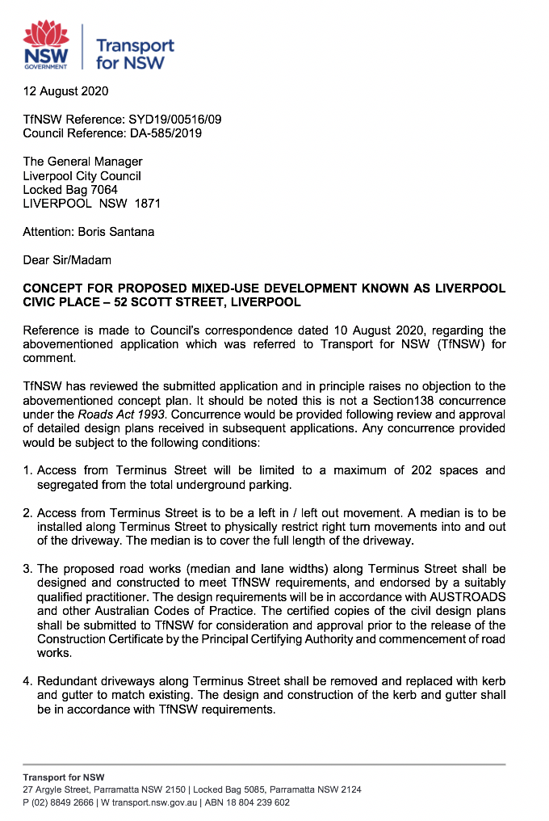
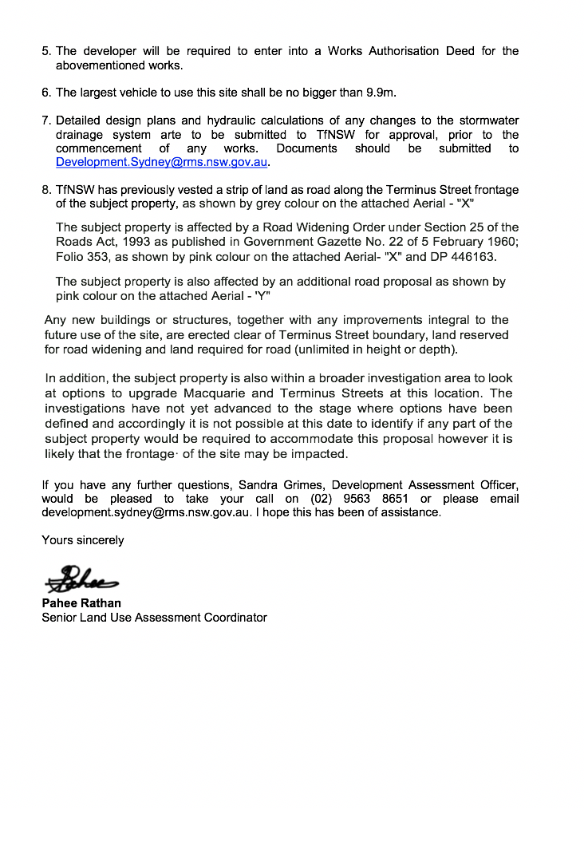
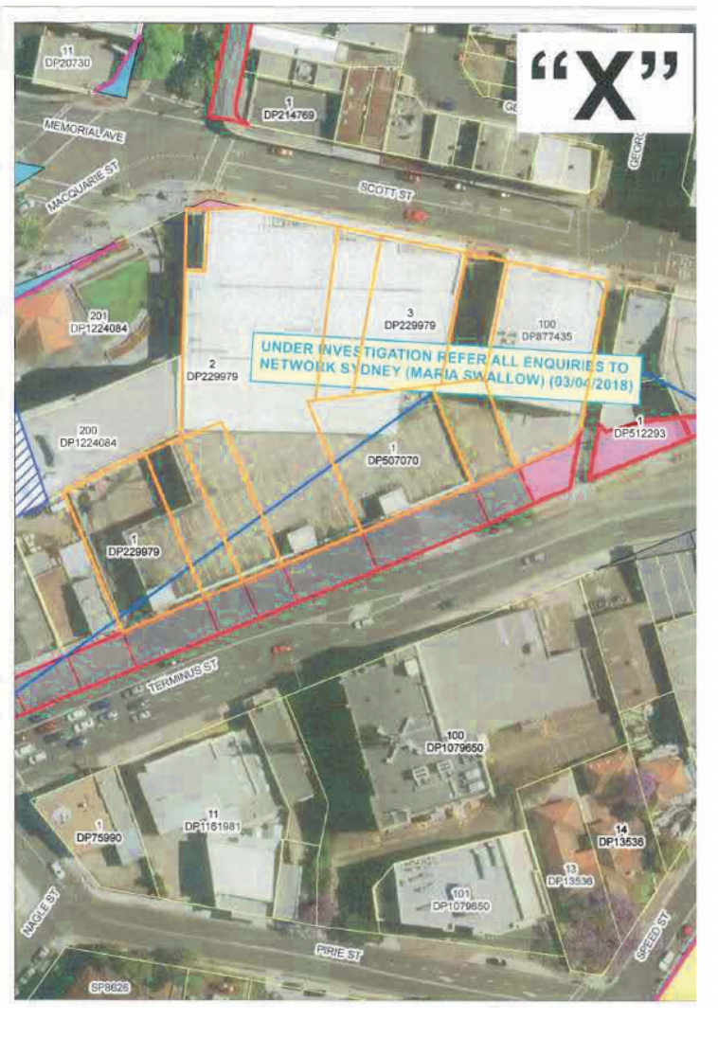
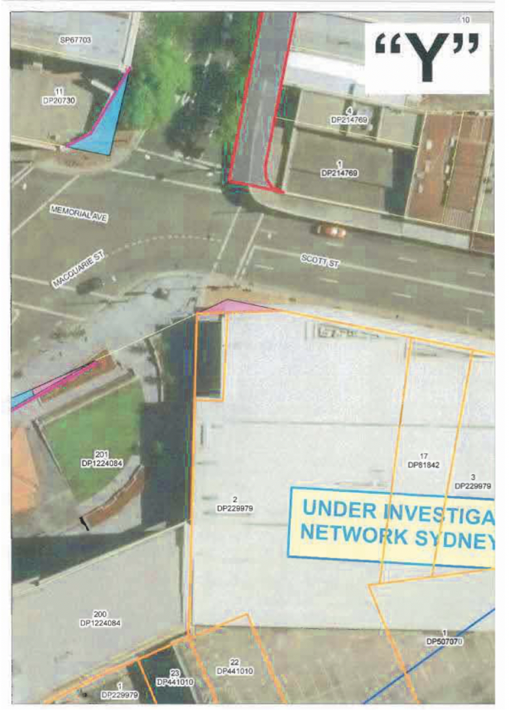
ATTACHMENT 2 – Sydney Water advice
